

**Collage name**

Collage address

Tribhuvan university

**Lab report of Numerical Method**

|  |  |
| --- | --- |
| **Submitted by:**  ……….  Semester: …..semester  Roll no: ….. | **Submitted to:**  Ajit poudyal  Lecturer |

Contents

Lab 1. solution of non linear equation 3

1. Bisection method 3

OR shorter codes 4

2. Netwon Raphson Method 6

3. Secant method 8

Lab2: interpolation and approximation 11

1. Lagrange interpolation 11

2. Newton interpolation using forward method 13

3. Newton interpolation using backward method 15

4. Newton interpolation using dividend method 17

Lab3: numerical differentiation and integration 20

1. Trapezoidal Rule 20

2. Simson’s 1/3 rule 22

3. Simson;s 3/8 Rule 24

Lab 4:solution of linear algebraic equation 26

1. Gauss elimination method 26

2. Gauss Jordan method 29

3. Matrix inversion using Gauss Jordan method 31

4. Matrix Factorization using Doolittle LU Decomposition 34

5. Matrix factorization using Cholesky’s method 37

6. Jacob iterative method 39

7. Gauss sedial iterative method 41

8. Power method 43

Lab5. Solution of ordinary differential equation 46

1. Talyor series 46

2. Picard’s method 48

3. Euler’s method 51

4. Heun’s method 53

5. Range-kutta method 55

6. Boundary value problem 57

7. Shooting method 62

# Lab 1. solution of non linear equation

## Bisection method

#include<stdio.h>

#include<conio.h>

#include<math.h>

#define f(x) cos(x) - x * exp(x)

void main()

{

float x0, x1, x2, f0, f1, f2, e;

int step = 1;

up:

printf("\nEnter two initial guesses:\n");

scanf("%f%f", &x0, &x1);

printf("Enter tolerable error:\n");

scanf("%f", &e);

f0 = f(x0);

f1 = f(x1);

if( f0 * f1 > 0.0)

{

printf("Incorrect Initial Guesses.\n");

goto up;

}

printf("\nStep\t\tx0\t\tx1\t\tx2\t\tf(x2)\n");

do

{

x2 = (x0 + x1)/2;

f2 = f(x2);

printf("%d\t\t%f\t%f\t%f\t%f\n",step, x0, x1, x2, f2);

if( f0 * f2 < 0)

{

x1 = x2;

f1 = f2;

}

else

{

x0 = x2;

f0 = f2;

}

step = step + 1;

}while(fabs(f2)>e);

printf("\nRoot is: %f", x2);

getch();

output:

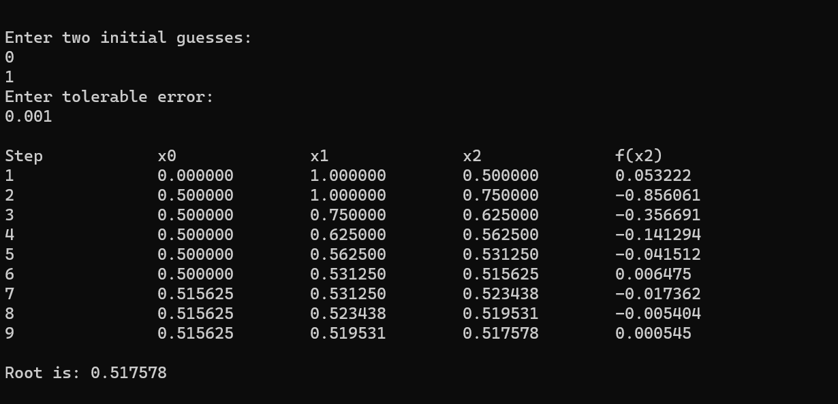

## OR shorter codes

#include<stdio.h>

#include<math.h>

#define f(x) cos(x)-x*exp(x)

void main() {

float a,b,c,fa,fb,fc,e;

do {

printf("Enter a, b: ");

scanf("%f%f",&a,&b);

fa=f(a); fb=f(b);

} while(fa*fb>0);

printf("Enter error: ");

scanf("%f",&e);

do {

c=(a+b)/2;

fc=f(c);

if(fa*fc<0) b=c,fb=fc;

else a=c,fa=fc;

} while(fabs(fc)>e);

printf("Root: %f",c);

}

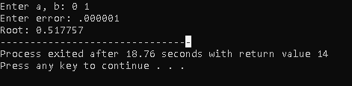

## Netwon Raphson Method

#include<conio.h>

#include<math.h>

#include<stdlib.h>

#define f(x) 3*x - cos(x) -1

#define g(x) 3 + sin(x)

void main()

{

float x0, x1, f0, f1, g0, e;

int step = 1, N;

printf("\nEnter initial guess:\n");

scanf("%f", &x0);

printf("Enter tolerable error:\n");

scanf("%f", &e);

printf("Enter maximum iteration:\n");

scanf("%d", &N);

printf("\nStep\t\tx0\t\tf(x0)\t\tx1\t\tf(x1)\n");

do

{

g0 = g(x0);

f0 = f(x0);

if(g0 == 0.0)

{

printf("Mathematical Error.");

exit(0);

}

x1 = x0 - f0/g0;

printf("%d\t\t%f\t%f\t%f\t%f\n",step,x0,f0,x1,f1);

x0 = x1;

step = step+1;

if(step > N)

{

printf("Not Convergent.");

exit(0);

}

f1 = f(x1);

}while(fabs(f1)>e);

printf("\nRoot is: %f", x1);

getch();

}

Output:

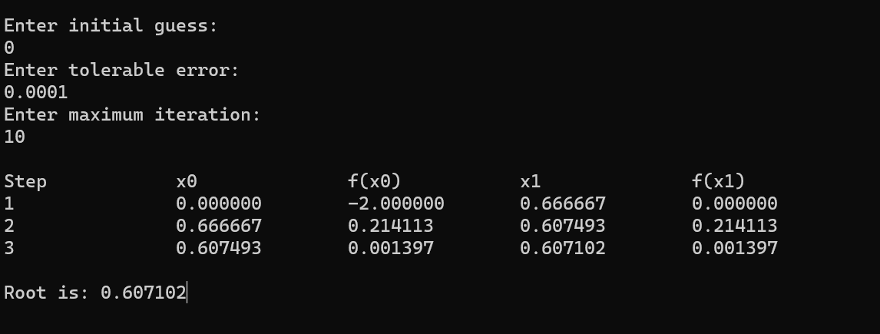

## S**ecant method**

#include<stdio.h>

#include<conio.h>

#include<math.h>

#include<stdlib.h>

#define f(x) x*x*x - 2*x - 5

void main()

{

float x0, x1, x2, f0, f1, f2, e;

int step = 1, N;

printf("\nEnter initial guesses:\n");

scanf("%f%f", &x0, &x1);

printf("Enter tolerable error:\n");

scanf("%f", &e);

printf("Enter maximum iteration:\n");

scanf("%d", &N);

printf("\nStep\t\tx0\t\tx1\t\tx2\t\tf(x2)\n");

do

{

f0 = f(x0);

f1 = f(x1);

if(f0 == f1)

{

printf("Mathematical Error.");

exit(0);

}

x2 = x1 - (x1 - x0) * f1/(f1-f0);

f2 = f(x2);

printf("%d\t\t%f\t%f\t%f\t%f\n",step,x0,x1,x2, f2);

x0 = x1;

f0 = f1;

x1 = x2;

f1 = f2;

step = step + 1;

if(step > N)

{

printf("Not Convergent.");

exit(0);

}

}while(fabs(f2)>e);

printf("\nRoot is: %f", x2);

getch();

output:

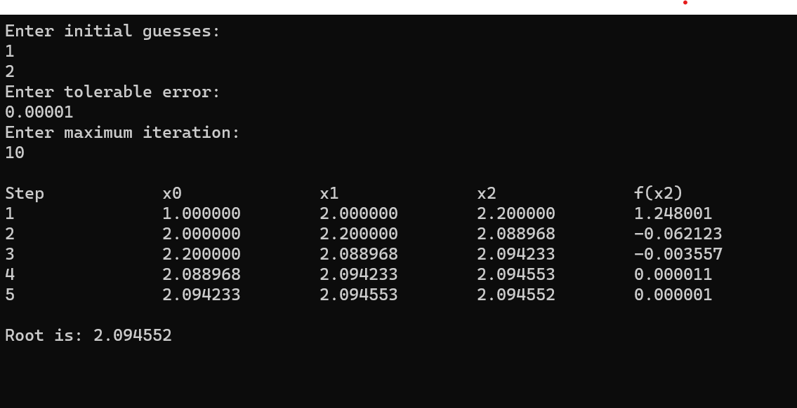

1. **False Position Method (Regula-Falsi Method)**

#include <stdio.h>

#include <math.h>

#define f(x) cos(x) - x*exp(x)

int main() {

float a, b, c, fa, fb, fc, e;

int step=1,N;

printf("Enter a, b, error: ");

scanf("%f%f%f", &a, &b, &e);

fa = f(a), fb = f(b);

if (fa * fb > 0) {

printf("No root here.\n");

return 1;

}

printf("\na\t\tb\t\tc\t\tf(a)\t\tf(b)\t\tf(c)\n");

do {

c = (a*fb - b*fa)/(fb - fa);

fc = f(c);

printf("%f\t%.6f\t%.6f\t% 6f\t%.6f\t% .6f\n", a, b, c, f(a),fb,fc);

if (fa * fc < 0)

b = c, fb = fc;

else

a = c, fa = fc;

} while (fabs(fc) > e);

printf("\nRoot: %.6f\n", c);

return 0;

}

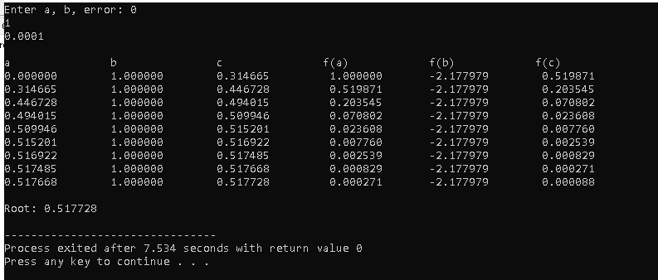

# Lab2: interpolation and approximation

## Lagrange interpolation

#include<stdio.h>

#include<conio.h>

void main()

{

float x[100], y[100], xp, yp=0, p;

int i,j,n;

printf("Enter number of data: ");

scanf("%d", &n);

printf("Enter data:\n");

for(i=1;i<=n;i++)

{

printf("x[%d] = ", i);

scanf("%f", &x[i]);

printf("y[%d] = ", i);

scanf("%f", &y[i]);

}

printf("Enter interpolation point: ");

scanf("%f", &xp);

for(i=1;i<=n;i++)

{

p=1;

for(j=1;j<=n;j++)

{

if(i!=j)

{

p = p* (xp - x[j])/(x[i] - x[j]);

}

}

yp = yp + p * y[i];

}

printf("Interpolated value at %.3f is %.3f.", xp, yp);

getch();

}

Output:

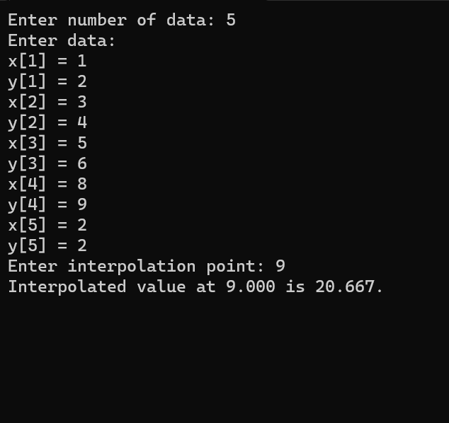

## Newton interpolation using forward method

#include<stdio.h>

#include<conio.h>

int main()

{

float x[20], y[20][20];

int i,j, n;

/* Input Section */

printf("Enter number of data?\n");

scanf("%d", &n);

printf("Enter data:\n");

for(i = 0; i < n ; i++)

{

printf("x[%d]=", i);

scanf("%f", &x[i]);

printf("y[%d]=", i);

scanf("%f", &y[i][0]);

}

for(i = 1; i < n; i++)

{

for(j = 0; j < n-i; j++)

{

y[j][i] = y[j+1][i-1] - y[j][i-1];

}

}

printf("\nFORWARD DIFFERENCE TABLE\n\n");

for(i = 0; i < n; i++)

{

printf("%0.2f", x[i]);

for(j = 0; j < n-i ; j++)

{

printf("\t%0.2f", y[i][j]);

}

printf("\n");

}

getch();

return 0;

}

Output:

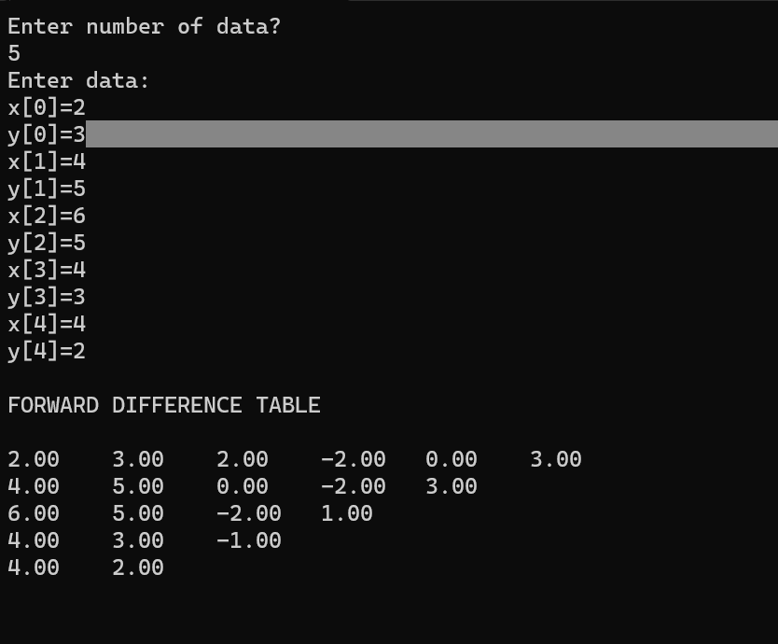

## Newton interpolation using backward method

#include<stdio.h>

#include<conio.h>

int main()

{

float x[20], y[20][20];

int i,j, n;

printf("Enter number of data?\n");

scanf("%d", &n);

printf("Enter data:\n");

for(i = 0; i < n ; i++)

{

printf("x[%d]=", i);

scanf("%f", &x[i]);

printf("y[%d]=", i);

scanf("%f", &y[i][0]);

}

for(i = 1; i < n; i++)

{

for(j = n-1; j > i-1; j--)

{

y[j][i] = y[j][i-1] - y[j-1][i-1];

}

}

printf("\nBACKWARD DIFFERENCE TABLE\n\n");

for(i = 0; i < n; i++)

{

printf("%0.2f", x[i]);

for(j = 0; j <= i ; j++)

{

printf("\t%0.2f", y[i][j]);

}

printf("\n");

}

getch();

return 0;

}

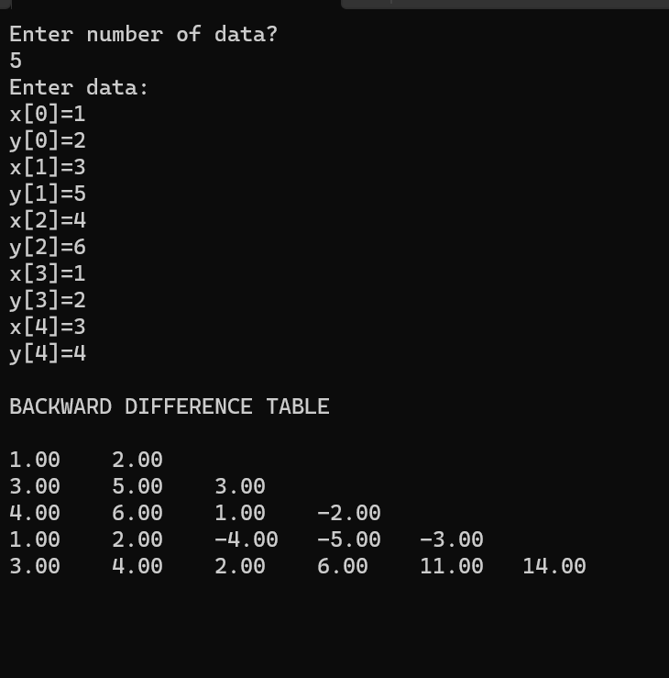

## Newton interpolation using dividend method

#include<stdio.h>

#include<conio.h>

void main()

{

int x[10], y[10], p[10];

int k,f,n,i,j=1,f1=1,f2=0;

printf("\nEnter the number of observations:\n");

scanf("%d", &n);

printf("\nEnter the different values of x:\n");

for (i=1;i<=n;i++)

scanf("%d", &x[i]);

printf("\nThe corresponding values of y are:\n");

for (i=1;i<=n;i++)

scanf("%d", &y[i]);

f=y[1];

printf("\nEnter the value of 'k' in f(k) you want to evaluate:\n");

scanf("%d", &k);

do

{

for (i=1;i<=n-1;i++)

{

p[i] = ((y[i+1]-y[i])/(x[i+j]-x[i]));

y[i]=p[i];

}

f1=1;

for(i=1;i<=j;i++)

{

f1*=(k-x[i]);

}

f2+=(y[1]*f1);

n--;

j++;

}

while(n!=1);

f+=f2;

printf("\nf(%d) = %d", k , f);

getch();

Output:

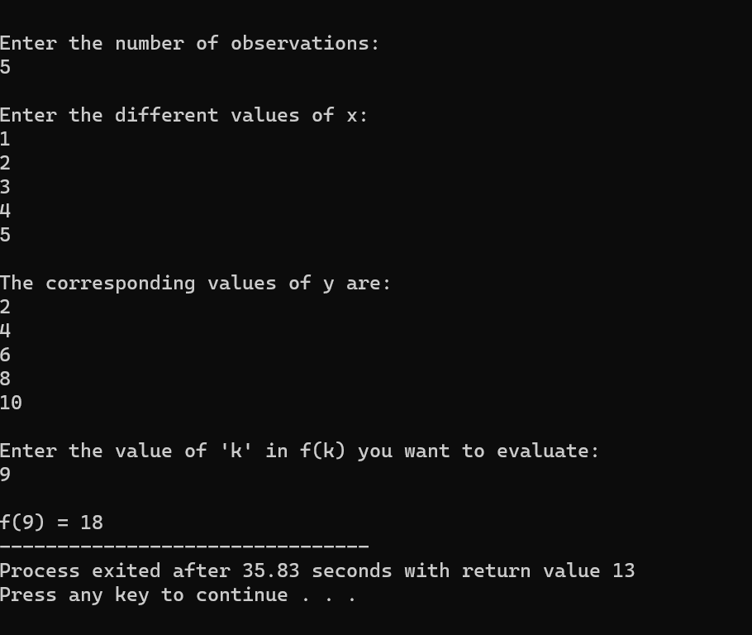

# Lab3: numerical differentiation and integration

## Trapezoidal Rule

#include<stdio.h>

#include<conio.h>

#include<math.h>

/* Define function here */

#define f(x) 1/(1+pow(x,2))

int main()

{

float lower, upper, integration=0.0, stepSize, k;

int i, subInterval;

printf("Enter lower limit of integration: ");

scanf("%f", &lower);

printf("Enter upper limit of integration: ");

scanf("%f", &upper);

printf("Enter number of sub intervals: ");

scanf("%d", &subInterval);

stepSize = (upper - lower)/subInterval;

integration = f(lower) + f(upper);

for(i=1; i<= subInterval-1; i++)

{

k = lower + i*stepSize;

integration = integration + 2 * f(k);

}

integration = integration * stepSize/2;

printf("\nRequired value of integration is: %.3f", integration);

getch();

return 0;

}

Output:

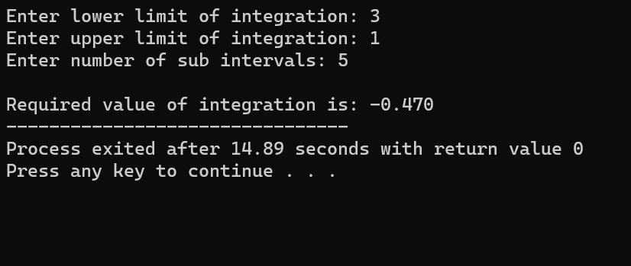

## Simson’s 1/3 rule

#include<stdio.h>

#include<conio.h>

#include<math.h>

#define f(x) 1/(1+x*x)

int main()

{

float lower, upper, integration=0.0, stepSize, k;

int i, subInterval;

printf("Enter lower limit of integration: ");

scanf("%f", &lower);

printf("Enter upper limit of integration: ");

scanf("%f", &upper);

printf("Enter number of sub intervals: ");

scanf("%d", &subInterval);

stepSize = (upper - lower)/subInterval;

integration = f(lower) + f(upper);

for(i=1; i<= subInterval-1; i++)

{

k = lower + i*stepSize;

if(i%2==0)

{

integration = integration + 2 * f(k);

}

else

{

integration = integration + 4 * f(k);

}

}

integration = integration * stepSize/3;

printf("\nRequired value of integration is: %.3f", integration);

getch();

return 0;

}

Output:

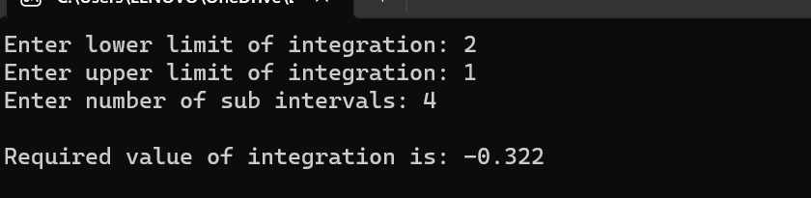

## Simson;s 3/8 Rule

#include<stdio.h>

#include<conio.h>

#include<math.h>

/* Define function here */

#define f(x) 1/(1+x*x)

int main()

{

float lower, upper, integration=0.0, stepSize, k;

int i, subInterval;

printf("Enter lower limit of integration: ");

scanf("%f", &lower);

printf("Enter upper limit of integration: ");

scanf("%f", &upper);

printf("Enter number of sub intervals: ");

scanf("%d", &subInterval);

stepSize = (upper - lower)/subInterval;

integration = f(lower) + f(upper);

for(i=1; i<= subInterval-1; i++)

{

k = lower + i*stepSize;

if(i%3 == 0)

{

integration = integration + 2 * f(k);

}

else

{

integration = integration + 3 * f(k);

}

}

integration = integration * stepSize*3/8;

printf("\nRequired value of integration is: %.3f", integration);

getch();

return 0;

}

Output:

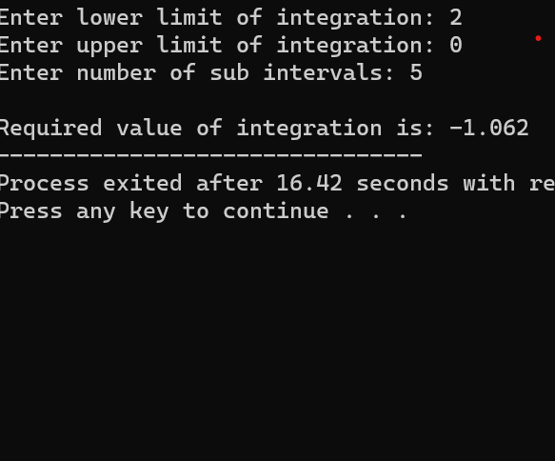

# Lab 4:solution of linear algebraic equation

## Gauss elimination method

#include<stdio.h>

#include<conio.h>

#include<math.h>

#include<stdlib.h>

#define SIZE 10

int main()

{

float a[SIZE][SIZE], x[SIZE], ratio;

int i,j,k,n;

printf("Enter number of unknowns: ");

scanf("%d", &n);

for(i=1;i<=n;i++)

{

for(j=1;j<=n+1;j++)

{

printf("a[%d][%d] = ",i,j);

scanf("%f", &a[i][j]);

}

}

for(i=1;i<=n-1;i++)

{

if(a[i][i] == 0.0)

{

printf("Mathematical Error!");

exit(0);

}

for(j=i+1;j<=n;j++)

{

ratio = a[j][i]/a[i][i];

for(k=1;k<=n+1;k++)

{

a[j][k] = a[j][k] - ratio*a[i][k];

}

}

}

x[n] = a[n][n+1]/a[n][n];

for(i=n-1;i>=1;i--)

{

x[i] = a[i][n+1];

for(j=i+1;j<=n;j++)

{

x[i] = x[i] - a[i][j]*x[j];

}

x[i] = x[i]/a[i][i];

}

printf("\nSolution:\n");

for(i=1;i<=n;i++)

{

printf("x[%d] = %0.3f\n",i, x[i]);

}

getch();

return(0);

}

Output:

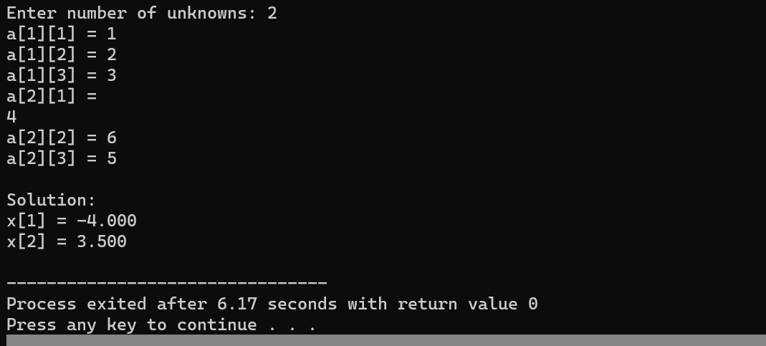

## Gauss Jordan method

#include<stdio.h>

#include<conio.h>

#include<math.h>

#define SIZE 10

int main()

{

float a[SIZE][SIZE], x[SIZE], ratio;

int i,j,k,n;

printf("Enter number of unknowns: ");

scanf("%d", &n);

printf("Enter coefficients of Augmented Matrix:\n");

for(i=1;i<=n;i++)

{

for(j=1;j<=n+1;j++)

{

printf("a[%d][%d] = ",i,j);

scanf("%f", &a[i][j]);

}

}

for(i=1;i<=n;i++)

{

if(a[i][i] == 0.0)

{

printf("Mathematical Error!");

exit(0);

}

for(j=1;j<=n;j++)

{

if(i!=j)

{ratio = a[j][i]/a[i][i];

for(k=1;k<=n+1;k++)

{

a[j][k] = a[j][k] - ratio*a[i][k];

} }} }

for(i=1;i<=n;i++)

{

x[i] = a[i][n+1]/a[i][i];

}

printf("\nSolution:\n");

for(i=1;i<=n;i++)

{

printf("x[%d] = %0.3f\n",i, x[i]);

}

getch();

return(0);

}

Output:

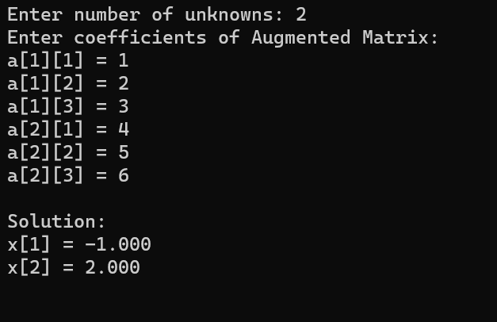

## Matrix inversion using Gauss Jordan method

#include<stdio.h>

#include<conio.h>

#include<math.h>

#include<stdlib.h>

#define SIZE 10

int main()

{

float a[SIZE][SIZE], x[SIZE], ratio;

int i,j,k,n;

printf("Enter number of unknowns: ");

scanf("%d", &n);

for(i=1;i<=n;i++)

{

for(j=1;j<=n+1;j++)

{

printf("a[%d][%d] = ",i,j);

scanf("%f", &a[i][j]);

}

}

/* Applying Gauss Elimination */

for(i=1;i<=n-1;i++)

{

if(a[i][i] == 0.0)

{

printf("Mathematical Error!");

exit(0);

}

for(j=i+1;j<=n;j++)

{

ratio = a[j][i]/a[i][i];

for(k=1;k<=n+1;k++)

{

a[j][k] = a[j][k] - ratio*a[i][k];

}

}

}

x[n] = a[n][n+1]/a[n][n];

for(i=n-1;i>=1;i--)

{

x[i] = a[i][n+1];

for(j=i+1;j<=n;j++)

{

x[i] = x[i] - a[i][j]*x[j];

}

x[i] = x[i]/a[i][i];

}

printf("\nSolution:\n");

for(i=1;i<=n;i++)

{

printf("x[%d] = %0.3f\n",i, x[i]);

}

getch();

return(0);

}

Output:



## Matrix Factorization using Doolittle LU Decomposition

#include<stdio.h>

#include<conio.h>

void main()

{

float A[20][20]= {0},L[20][20]= {0}, U[20][20];

float B[20]= {0}, X[20]= {0},Y[20]= {0};

int i,j,k,n;

printf("Enter the order of square matrix: ");

scanf("%d",&n);

printf("\nEnter matrix element:\n");

for(i=0; i<n; i++)

{

for(j=0; j<n; j++)

{

printf("Enter A[%d][%d] element: ", i,j);

scanf("%f",&A[i][j]);

}

}

printf("\nEnter the constant terms: \n");

for(i=0; i<n; i++)

{

printf("B[%d]",i);

scanf("%f",&B[i]);

}

for(j=0; j<n; j++)

{

for(i=0; i<n; i++)

{

if(i<=j)

{

U[i][j]=A[i][j];

for(k=0; k<i-1; k++)

U[i][j]-=L[i][k]*U[k][j];

if(i==j)

L[i][j]=1;

else

L[i][j]=0;

}

else

{

L[i][j]=A[i][j];

for(k=0; k<=j-1; k++)

L[i][j]-=L[i][k]*U[k][j];

L[i][j]/=U[j][j];

U[i][j]=0;

}

}

}

printf("[L]: \n");

for(i=0; i<n; i++)

{

for(j=0; j<n; j++)

printf("%9.3f",L[i][j]);

printf("\n");

}

printf("\n\n[U]: \n");

for(i=0; i<n; i++)

{

for(j=0; j<n; j++)

printf("%9.3f",U[i][j]);

printf("\n");

}

for(i=0; i<n; i++)

{

Y[i]=B[i];

for(j=0; j<i; j++)

{

Y[i]-=L[i][j]*Y[j];

}

}

printf("\n\n[Y]: \n");

for(i=0; i<n; i++)

{

printf("%9.3f",Y[i]);

}

for(i=n-1; i>=0; i--)

{

X[i]= Y[i];

for(j=i+1; j<n; j++)

{

X[i]-=U[i][j]*X[j];

}

X[i]/=U[i][i];

}

printf("\n\n[X]: \n");

for(i=0; i<n; i++)

{

printf("%9.3f",X[i]);

}

getch();

}

Output:

,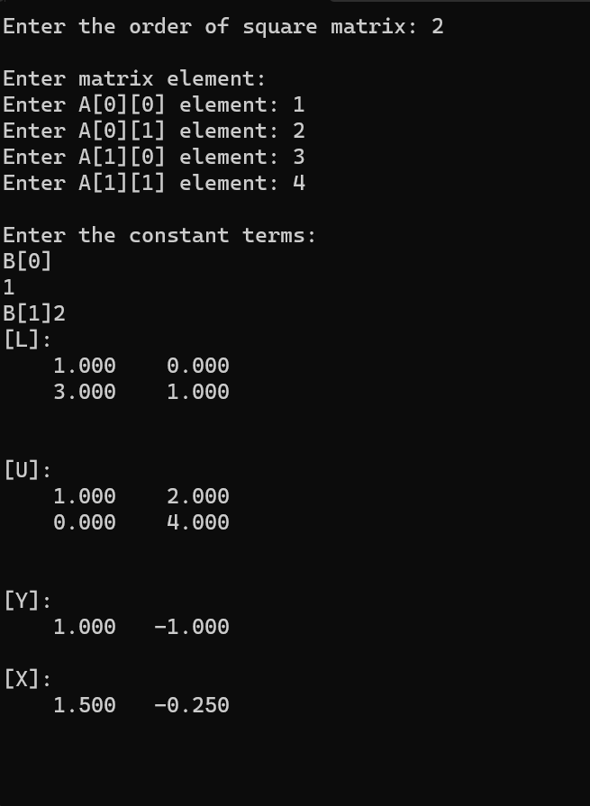

## Matrix factorization using Cholesky’s method

#include <stdio.h>

#include <stdlib.h>

#include <math.h>

double *cholesky(double *A, int n) {

double *L = (double*)calloc(n * n, sizeof(double));

if (L == NULL)

exit(EXIT_FAILURE);

for (int i = 0; i < n; i++)

for (int j = 0; j < (i+1); j++) {

double s = 0;

for (int k = 0; k < j; k++)

s += L[i * n + k] * L[j * n + k];

L[i * n + j] = (i == j) ?

sqrt(A[i * n + i] - s) :

(1.0 / L[j * n + j] * (A[i * n + j] - s));

}

return L;

}

void show_matrix(double *A, int n) {

for (int i = 0; i < n; i++) {

for (int j = 0; j < n; j++)

printf("%2.5f ", A[i * n + j]);

printf("\n");

}

}

int main() {

int n = 3;

double m1[] = {25, 15, -5,

15, 18, 0,

-5, 0, 11};

double *c1 = cholesky(m1, n);

show_matrix(c1, n);

printf("\n");

free(c1);

n = 4;

double m2[] = {18, 22, 54, 42,

22, 70, 86, 62,

54, 86, 174, 134,

42, 62, 134, 106};

double *c2 = cholesky(m2, n);

show_matrix(c2, n);

free(c2);

return 0;

}

Output:

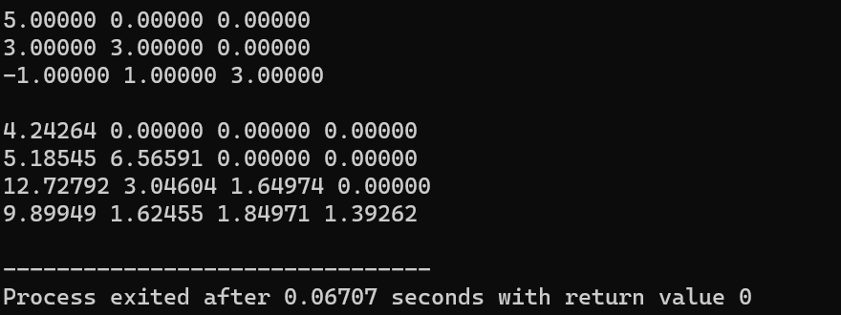

## Jacob iterative method

#include<stdio.h>

#include<conio.h>

#include<math.h>

#define f1(x,y,z) (17-y+2*z)/20

#define f2(x,y,z) (-18-3*x+z)/20

#define f3(x,y,z) (25-2*x+3*y)/20

/* Main function */

int main()

{

float x0=0, y0=0, z0=0, x1, y1, z1, e1, e2, e3, e;

int count=1;

printf("Enter tolerable error:\n");

scanf("%f", &e);

printf("\nCount\tx\ty\tz\n");

do

{

/* Calculation */

x1 = f1(x0,y0,z0);

y1 = f2(x0,y0,z0);

z1 = f3(x0,y0,z0);

printf("%d\t%0.4f\t%0.4f\t%0.4f\n",count, x1,y1,z1);

e1 = fabs(x0-x1);

e2 = fabs(y0-y1);

e3 = fabs(z0-z1);

count++;

x0 = x1;

y0 = y1;

z0 = z1;

}while(e1>e && e2>e && e3>e);

printf("\nSolution: x=%0.3f, y=%0.3f and z = %0.3f\n",x1,y1,z1);

getch();

return 0;

}

Output:

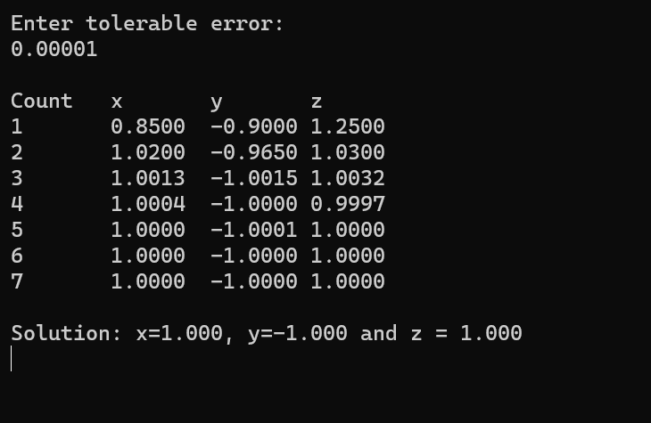

## Gauss sedial iterative method

#include<stdio.h>

#include<conio.h>

#include<math.h>

#define f1(x,y,z) (17-y+2*z)/20

#define f2(x,y,z) (-18-3*x+z)/20

#define f3(x,y,z) (25-2*x+3*y)/20

/* Main function */

int main()

{

float x0=0, y0=0, z0=0, x1, y1, z1, e1, e2, e3, e;

int count=1;

printf("Enter tolerable error:\n");

scanf("%f", &e);

printf("\nCount\tx\ty\tz\n");

do

{

/* Calculation */

x1 = f1(x0,y0,z0);

y1 = f2(x1,y0,z0);

z1 = f3(x1,y1,z0);

printf("%d\t%0.4f\t%0.4f\t%0.4f\n",count, x1,y1,z1);

/* Error */

e1 = fabs(x0-x1);

e2 = fabs(y0-y1);

e3 = fabs(z0-z1);

count++;

/* Set value for next iteration */

x0 = x1;

y0 = y1;

z0 = z1;

}while(e1>e && e2>e && e3>e);

printf("\nSolution: x=%0.3f, y=%0.3f and z = %0.3f\n",x1,y1,z1);

getch();

return 0;

}

Output:

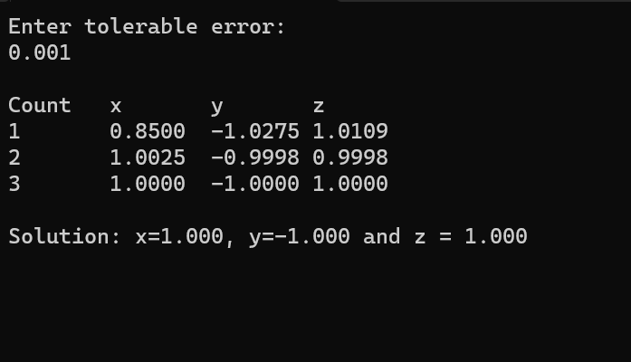

## Power method

#include<stdio.h>

#include<conio.h>

#include<math.h>

#define SIZE 10

int main()

{

float a[SIZE][SIZE], x[SIZE],x_new[SIZE];

float temp, lambda_new, lambda_old, error;

int i,j,n, step=1;

/* Inputs */

printf("Enter Order of Matrix: ");

scanf("%d", &n);

printf("Enter Tolerable Error: ");

scanf("%f", &error);

/* Reading Matrix */

printf("Enter Coefficient of Matrix:\n");

for(i=1;i<=n;i++)

{

for(j=1;j<=n;j++)

{

printf("a[%d][%d]=",i,j);

scanf("%f", &a[i][j]);

}

}

/* Reading Intial Guess Vector */

printf("Enter Initial Guess Vector:\n");

for(i=1;i<=n;i++)

{

printf("x[%d]=",i);

scanf("%f", &x[i]);

}

/* Initializing Lambda_Old */

lambda_old = 1;

/* Multiplication */

up:

for(i=1;i<=n;i++)

{

temp = 0.0;

for(j=1;j<=n;j++)

{

temp = temp + a[i][j]*x[j];

}

x_new[i] = temp;

}

/* Replacing */

for(i=1;i<=n;i++)

{

x[i] = x_new[i];

}

/* Finding Largest */

lambda_new = fabs(x[1]);

for(i=2;i<=n;i++)

{

if(fabs(x[i])>lambda_new)

{

lambda_new = fabs(x[i]);

}

}

/* Normalization */

for(i=1;i<=n;i++)

{

x[i] = x[i]/lambda_new;

}

/* Display */

printf("\n\nSTEP-%d:\n", step);

printf("Eigen Value = %f\n", lambda_new);

printf("Eigen Vector:\n");

for(i=1;i<=n;i++)

{

printf("%f\t", x[i]);

}

/* Checking Accuracy */

if(fabs(lambda_new-lambda_old)>error)

{

lambda_old=lambda_new;

step++;

goto up;

}

getch();

return(0);

}

Output:

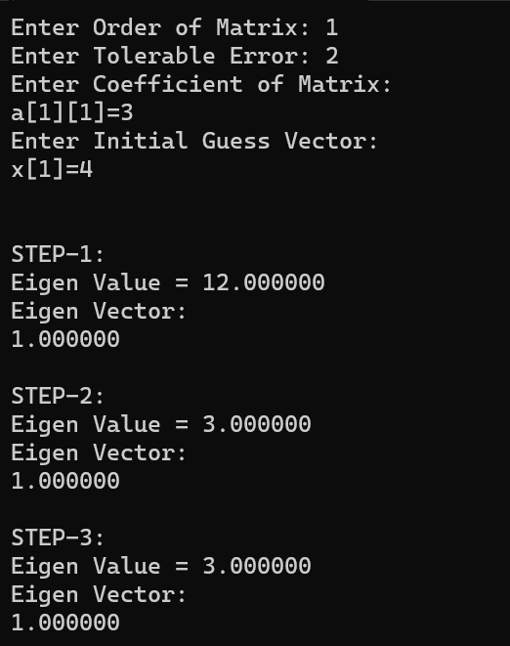

# Lab5. Solution of ordinary differential equation

## Talyor series

#include<stdio.h>

#include<math.h>

int main()

{

int x,i;

int fact = 1,n;

float sum=0;

printf("\n\nEnter the value of x in the series : ");

scanf("%d",&x);

printf("\nEnter the number of terms in the series : ");

scanf("%d",&n);

for(i=1;i<n;i++)

{

fact = fact*i;

sum = sum + (pow(x,i)/fact) ;

}

sum= sum +1; //Since series starts with 1

printf("\nThe sum of the taylor series is : %.2f\n\n",sum);

return 0;

}

Output:

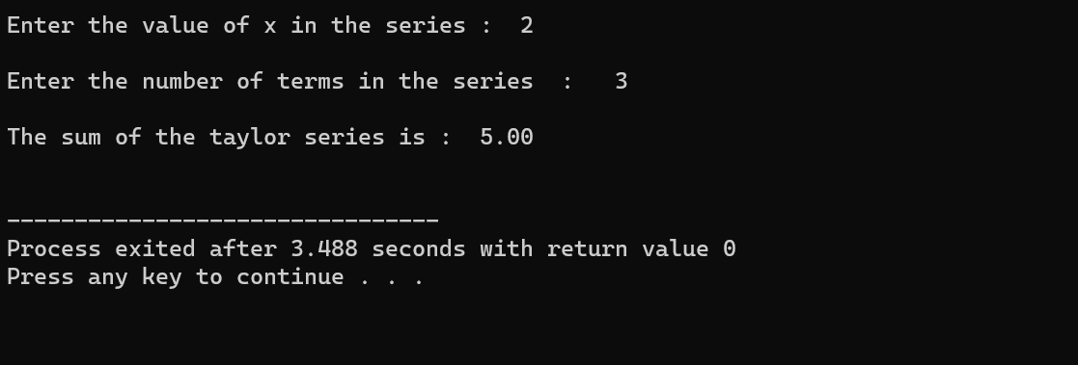

## Picard’s method

#include <math.h>

#include <stdio.h>

#define Y1(x) (1 + (x) + pow(x, 2) / 2)

#define Y2(x) (1 + (x) + pow(x, 2) / 2 + pow(x, 3) / 3 + pow(x, 4) / 8)

#define Y3(x) (1 + (x) + pow(x, 2) / 2 + pow(x, 3) / 3 + pow(x, 4) / 8 + pow(x, 5) / 15 + pow(x, 6) / 48)

int main()

{

double start_value = 0, end_value = 3,

allowed_error = 0.4, temp;

double y1[30], y2[30], y3[30];

int count;

for (temp = start_value, count = 0;

temp <= end_value;

temp = temp + allowed_error, count++) {

y1[count] = Y1(temp);

y2[count] = Y2(temp);

y3[count] = Y3(temp);

}

printf("\nX\n");

for (temp = start_value;

temp <= end_value;

temp = temp + allowed_error) {

printf("%.4lf ", temp);

}

printf("\n\nY(1)\n");

for (temp = start_value, count = 0;

temp <= end_value;

temp = temp + allowed_error, count++) {

printf("%.4lf ", y1[count]);

}

printf("\n\nY(2)\n");

for (temp = start_value, count = 0;

temp <= end_value;

temp = temp + allowed_error, count++) {

printf("%.4lf ", y2[count]);

}

printf("\n\nY(3)\n");

for (temp = start_value, count = 0;

temp <= end_value;

temp = temp + allowed_error, count++) {

printf("%.4lf ", y3[count]);

}

return 0;

}

Output:

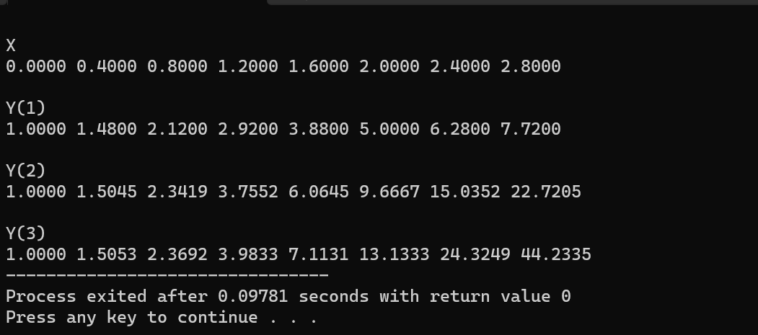

## Euler’s method

#include<stdio.h>

#include<conio.h>

#define f(x,y) x+y

int main()

{

float x0, y0, xn, h, yn, slope;

int i, n;

printf("Enter Initial Condition\n");

printf("x0 = ");

scanf("%f", &x0);

printf("y0 = ");

scanf("%f", &y0);

printf("Enter calculation point xn = ");

scanf("%f", &xn);

printf("Enter number of steps: ");

scanf("%d", &n);

/* Calculating step size (h) */

h = (xn-x0)/n;

/* Euler's Method */

printf("\nx0\ty0\tslope\tyn\n");

printf("------------------------------\n");

for(i=0; i < n; i++)

{

slope = f(x0, y0);

yn = y0 + h * slope;

printf("%.4f\t%.4f\t%0.4f\t%.4f\n",x0,y0,slope,yn);

y0 = yn;

x0 = x0+h;

}

/* Displaying result */

printf("\nValue of y at x = %0.2f is %0.3f",xn, yn);

getch();

return 0;

}

Output:

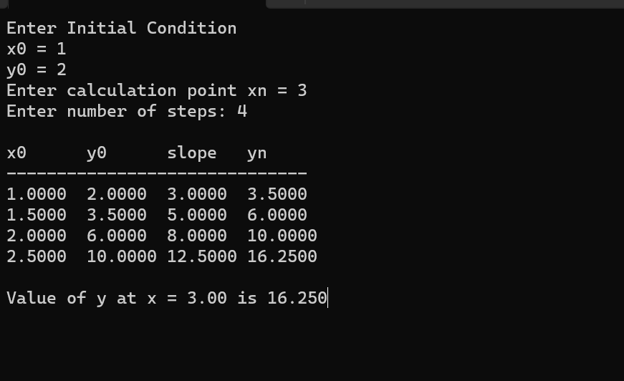

## Heun’s method

#include<conio.h>

#include<stdio.h>

#define f(x,y) 2*y/x

void main()

{

float x,y,h,xn,l;

printf("Program for Solution of Ordinary Differential Equation\nHeun's Method\n");

printf("Enter value for x and y\n");

scanf("%f%f",&x,&y);

printf("Enter value for h and last of x\n");

scanf("%f%f",&h,&xn);

while(x+h<=xn)

{

l=(h/2)*(f(x,y)+f(x+h,y+h*f(x,y)));

y=y+l;

x=x+h;

printf("y = %f\tx = %f\n",y,x);

}

getch();

}

Output:

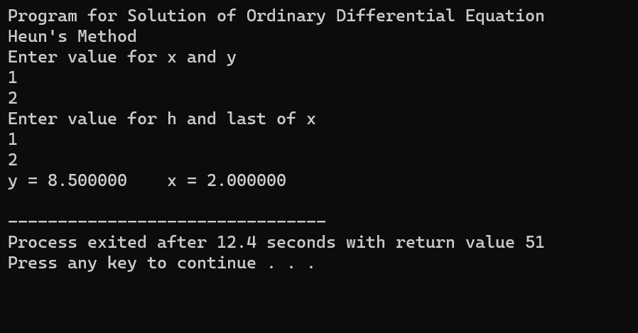

## Range-kutta method

#include<stdio.h>

#include<conio.h>

#define f(x,y) (y*y-x*x)/(y*y+x*x)

int main()

{

float x0, y0, xn, h, yn, k1, k2, k3, k4, k;

int i, n;

printf("Enter Initial Condition\n");

printf("x0 = ");

scanf("%f", &x0);

printf("y0 = ");

scanf("%f", &y0);

printf("Enter calculation point xn = ");

scanf("%f", &xn);

printf("Enter number of steps: ");

scanf("%d", &n);

h = (xn-x0)/n;

printf("\nx0\ty0\tyn\n");

for(i=0; i < n; i++)

{

k1 = h * (f(x0, y0));

k2 = h * (f((x0+h/2), (y0+k1/2)));

k3 = h * (f((x0+h/2), (y0+k2/2)));

k4 = h * (f((x0+h), (y0+k3)));

k = (k1+2*k2+2*k3+k4)/6;

yn = y0 + k;

printf("%0.4f\t%0.4f\t%0.4f\n",x0,y0,yn);

x0 = x0+h;

y0 = yn;

}

printf("\nValue of y at x = %0.2f is %0.3f",xn, yn);

getch();

return 0;

}

Output:

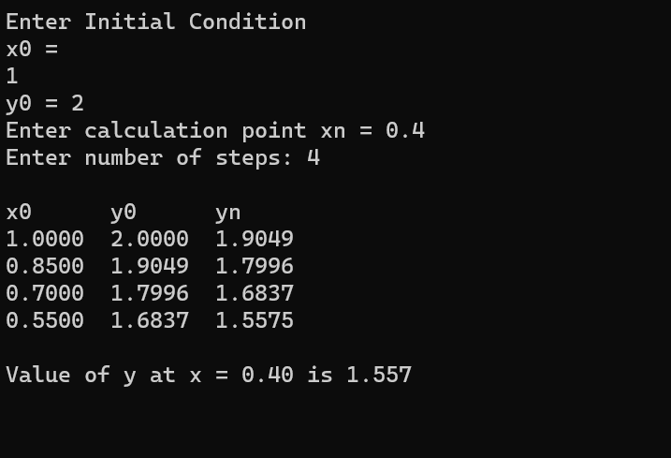

## Boundary value problem

#include<stdio.h>

#include<math.h>

#include<stdlib.h>

float f1(float x, float y, float z)

{

return(z);

}

float f2(float x, float y, float z)

{

return(x + y);

}

float shoot(float x0, float y0, float z0, float xn, float h, int p)

{

float x, y, z, k1, k2, k3, k4, l1, l2, l3, l4, k, l, x1, y1, z1;

x = x0;

y = y0;

z = z0;

do

{

k1 = h * f1(x, y, z);

l1 = h * f2(x, y, z);

k2 = h * f1(x + h / 2.0, y + k1 / 2.0, z + l1 / 2.0);

l2 = h * f2(x + h / 2.0, y + k1 / 2.0, z + l1 / 2.0);

k3 = h * f1(x + h / 2.0, y + k2 / 2.0, z + l2 / 2.0);

l3 = h * f2(x + h / 2.0, y + k2 / 2.0, z + l2 / 2.0);

k4 = h * f1(x + h, y + k3, z + l3);

l4 = h * f2(x + h, y + k3, z + l3);

l = 1 / 6.0 * (l1 + 2 * l2 + 2 * l3 + l4);

k = 1 / 6.0 * (k1 + 2 * k2 + 2 * k3 + k4);

y1 = y + k;

x1 = x + h;

z1 = z + l;

x = x1;

y = y1;

z = z1;

if (p == 1)

{

printf("\n%f\t%f", x, y);

}

} while (x < xn);

return(y);

}

main()

{

float x0, y0, h, xn, yn, z0, m1, m2, m3, b, b1, b2, b3, e;

int p = 0;

printf("\n Enter x0,y0,xn,yn,h:");

scanf("%f%f%f%f%f", &x0, &y0, &xn, &yn, &h);

printf("\n Enter the trial M1:");

scanf("%f", &m1);

b = yn;

z0 = m1;

b1 = shoot(x0, y0, z0, xn, h, p = 1);

printf("\nB1 is %f", b1);

if (fabs(b1 - b) < 0.00005)

{

printf("\n The value of x and respective z are:\n");

e = shoot(x0, y0, z0, xn, h, p = 1);

return(0);

}

else

{

printf("\nEnter the value of M2:");

scanf("%f", &m2);

z0 = m2;

b2 = shoot(x0, y0, z0, xn, h, p = 1);

printf("\nB2 is %f", b2);

}

if (fabs(b2 - b) < 0.00005)

{

printf("\n The value of x and respective z are\n");

e = shoot(x0, y0, z0, xn, h, p = 1);

return(0);

}

else

{

printf("\nM2=%f\tM1=%f", m2, m1);

m3 = m2 - ((m2 - m1) / (b2 - b1)) * (b2 - b);

if (b1 - b2 == 0)

exit(0);

printf("\nExact value of M =%f", m3);

z0 = m3;

b3 = shoot(x0, y0, z0, xn, h, p = 0);

}

if (fabs(b3 - b) < 0.000005)

{

printf("\nThere is solution :\n");

e = shoot(x0, y0, z0, xn, h, p = 1);

exit(0);

}

do

{

m1 = m2;

m2 = m3;

b1 = b2;

b2 = b3;

m3 = m2 - ((m2 - m1) / (b2 - b1)) * (b2 - b);

z0 = m3;

b3 = shoot(x0, y0, z0, xn, h, p = 0);

} while (fabs(b3 - b) < 0.0005);

z0 = m3;

e = shoot(x0, y0, z0, xn, h, p = 1);

}

Output:

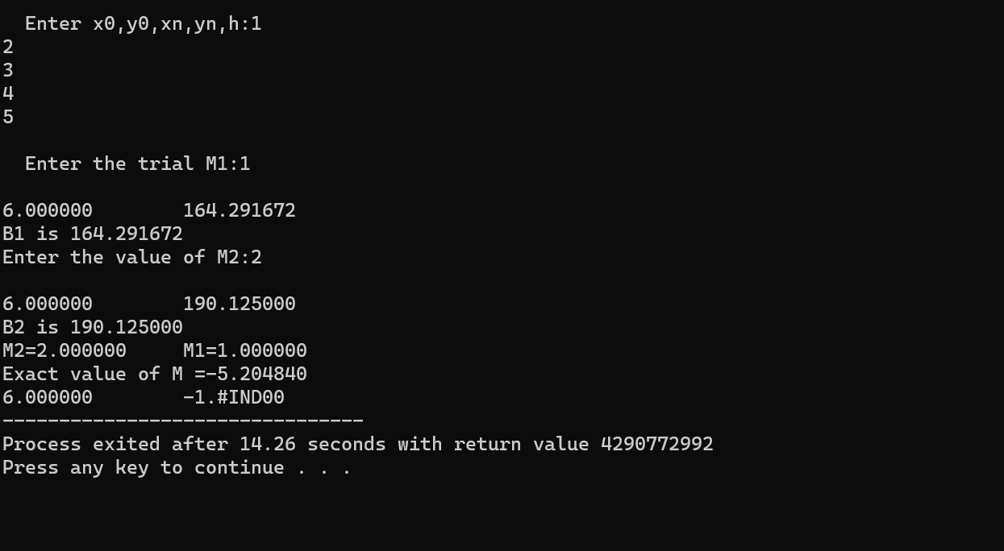

## Shooting method

#include<stdio.h>

#include<math.h>

#include<stdlib.h>

float f1(float x,float y,float z)

{

return(z);

}

float f2(float x,float y,float z)

{

return(x+y);

}

float shoot(float x0,float y0,float z0,float xn,float h,int p)

{

float x,y,z,k1,k2,k3,k4,l1,l2,l3,l4,k,l,x1,y1,z1;

x=x0;

y=y0;

z=z0;

do

{

k1=h*f1(x,y,z);

l1=h*f2(x,y,z);

k2=h*f1(x+h/2.0,y+k1/2.0,z+l1/2.0);

l2=h*f2(x+h/2.0,y+k1/2.0,z+l1/2.0);

k3=h*f1(x+h/2.0,y+k2/2.0,z+l2/2.0);

l3=h*f2(x+h/2.0,y+k2/2.0,z+l2/2.0);

k4=h*f1(x+h,y+k3,z+l3);

l4=h*f2(x+h,y+k3,z+l3);

l=1/6.0*(l1+2*l2+2*l3+l4);

k=1/6.0*(k1+2*k2+2*k3+k4);

y1=y+k;

x1=x+h;

z1=z+l;

x=x1;

y=y1;

z=z1;

if(p==1)

{

printf("\n%f\t%f",x,y);

}

}while(x<xn);

return(y);

}

void main()

{

float x0,y0,h,xn,yn,z0,m1,m2,m3,b,b1,b2,b3,e;

int p=0;

printf("\n Enter x0,y0,xn,yn,h:");

scanf("%f%f%f%f%f",&x0,&y0,&xn,&yn,&h);

printf("\n Enter the trial M1:");

scanf("%f",&m1);

b=yn;

z0=m1;

b1=shoot(x0,y0,z0,xn,h,p=1);

printf("\nB1 is %f",b1);

if(fabs(b1-b)<0.00005)

{

printf("\n The value of x and respective z are:\n");

e=shoot(x0,y0,z0,xn,h,p=1);

return(0);

}

else

{

printf("\nEnter the value of M2:");

scanf("%f",&m2);

z0=m2;

b2=shoot(x0,y0,z0,xn,h,p=1);

printf("\nB2 is %f",b2);

}

if(fabs(b2-b)<0.00005)

{

printf("\n The value of x and respective z are\n");

e= shoot(x0,y0,z0,xn,h,p=1);

return(0);

}

else

{

printf("\nM2=%f\tM1=%f",m2,m1);

m3=m2+(((m2-m1)*(b-b2))/(1.0*(b2-b1)));

if(b1-b2==0)

exit(0);

printf("\nExact value of M =%f",m3);

z0=m3;

b3=shoot(x0,y0,z0,xn,h,p=0);

}

if(fabs(b3-b)<0.000005)

{

printf("\nThere is solution :\n");

e=shoot(x0,y0,z0,xn,h,p=1);

exit(0);

}

do

{

m1=m2;

m2=m3;

b1=b2;

b2=b3;

m3=m2+(((m2-m1)*(b-b2))/(1.0*(b2-b1)));

z0=m3;

b3=shoot(x0,y0,z0,xn,h,p=0);

}while(fabs(b3-b)<0.0005);

z0=m3;

e=shoot(x0,y0,z0,xn,h,p=1);

}

Output:

